MEMORY

The process where the programs and services are allocated dedicated to virtual memory spaces

Stack Memory🡪 Static Memory Allocation

Eg: primitive

Heap Memory🡪 Dynamic Memory Allocation

Eg: Non-primitive

To find out the memory:

System.identityHashCode(refName);

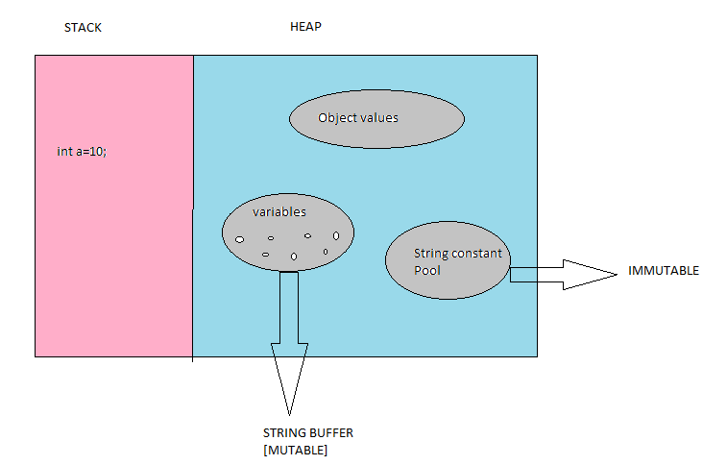

Example:

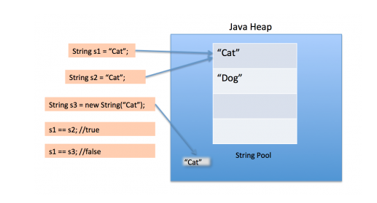

**Immutable**:

Syntax: String refName=” “;

String s=”Welcome to java”;

When we do:

Duplicate value: it will share the memory

Concordination: it will create new memory [s=s1+s2]

**Mutable**:

Syntax: StringBuffer refName=new StringBuffer(“ “);

When we do:

Duplicate Value: it will create a new memory.

Append: Memory will be shared [s=s.append(s2)]

STRING BUFFER:

* It is a mutable
* Synchronized
* One by one process, it is a thread safe. But it is a slow process

THREAD🡪 It allows a program to operate more efficient by doing multiple things as the same time.

STRING BUILDER:

* It is a mutable
* Asynchronized
* It is not thread safe, but it Is fast process.